**PYTHON NANG CAO LAB_5**

**Tên: PHIMMACHAK Lattakone**

**MSSV:227480201is001**

**CÂU1**. Cài đặt và kết nối với máy chủ MySQL từ Python

**SHOW DATABASES**

**1.1 Tạo file MySQL-connect.py**

**Kết quả sau khi chạy code: Connected to MySQL Database**



**Câu 2:** Định cấu hình kết nối cơ sở dữ liệu MySQL

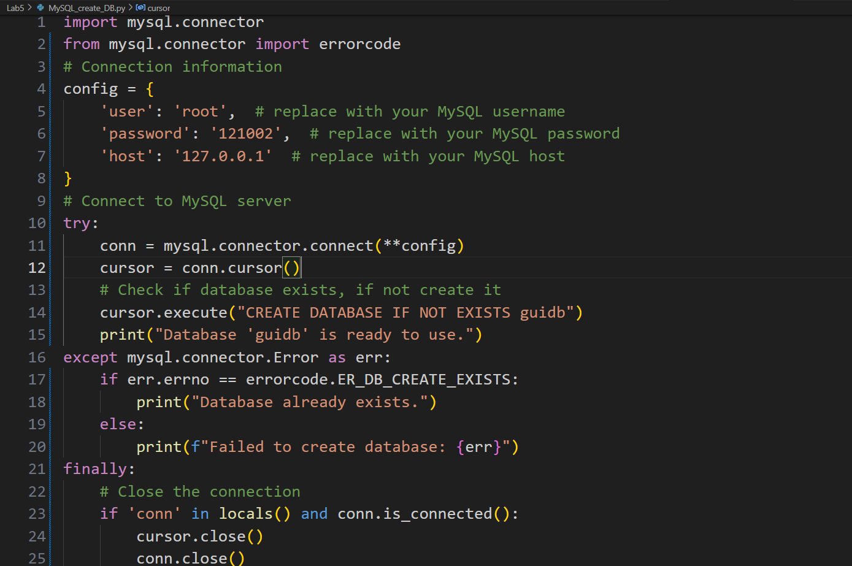

**Kết quả sau tạo Guidb: Database ‘guidb’ is ready to use**

**Tạo module mới (MySQL_show_DBs.py)**

**Kết quả module mới:**



**Câu3.** Thiết kế cơ sở dữ liệu GUI Python

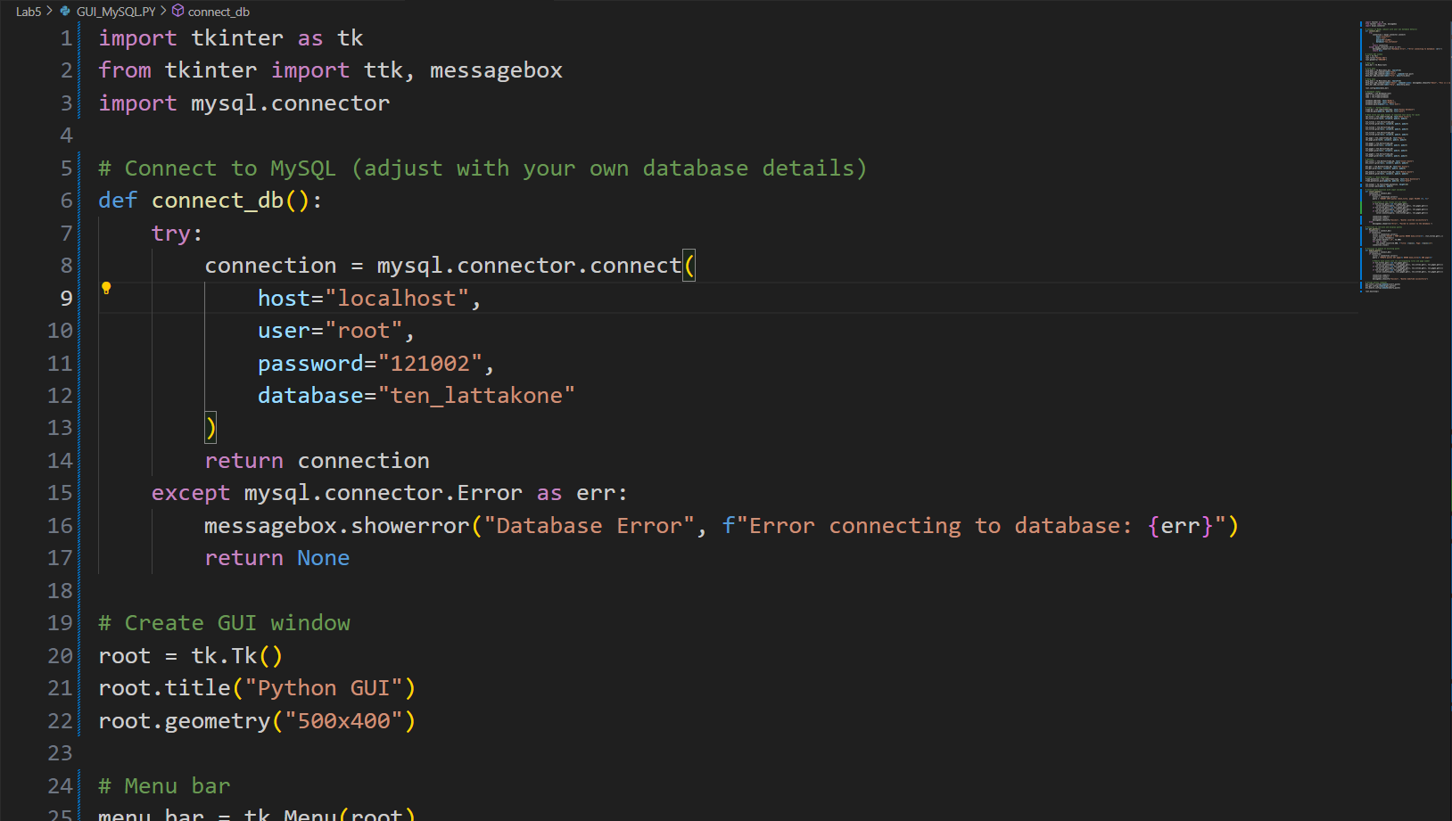

**Kết quả 3:** Thiết kế cơ sở dữ liệu GUI Python

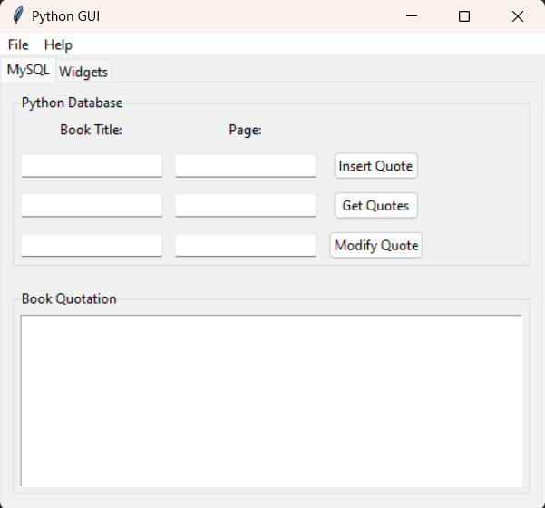

**Câu4:** Sử dụng lệnh SQL INSERT

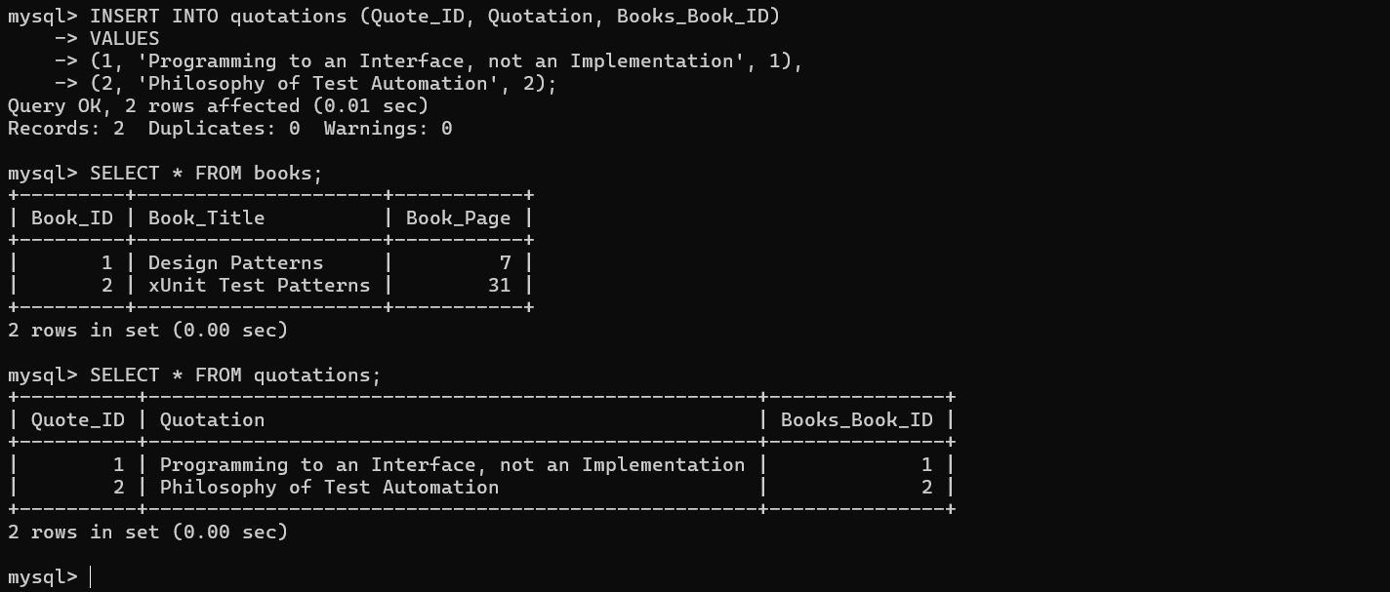

**Câu5:** Sử dụng lệnh SQL UPDATE

**Kết quả5:**

**Trong Command MySQL:**

**Câu6:** Sử dụng lệnh SQL DELETE

**Kết quả6:**



**Trong Command MySQL:**

**Câu7:**

**Kết quả 7:**

**Câu 8.Sử dụng MySQL Workbench**

